Experiment No. 8

Generate the following two result sets:

**1).** Query an alphabetically ordered list of all names in OCCUPATIONS, immediately followed by the first letter of each profession as a parenthetical (i.e.: enclosed in parentheses). For example: AnActorName(A), ADoctorName(D), AProfessorName(P), and ASingerName(S).

**2).** Query the number of ocurrences of each occupation in OCCUPATIONS. Sort the occurrences in ascending order, and output them in the following format:

There are total [occupation_count] [occupation]s.

Table Name: Occupations

Total Columns: Two = 'Name' and 'Occupation', demo table is shown below:

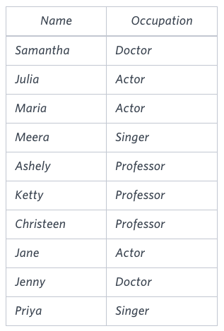

*First Query*

1. The first query wants to display the Name of the person and only the first letter of the Occupation.
2. To find the first letter of occupation we can use [LEFT()](https://dev.mysql.com/doc/refman/8.0/en/string-functions.html#function_left) function of MYSQL and [SUBSTRING()](https://docs.oracle.com/cd/B28359_01/olap.111/b28126/dml_functions_2101.htm#OLADM679) function of Oracle.
3. To give output as “Name(O)”, we can use CONCAT() function in MYSQL and [CONCAT()](https://docs.oracle.com/cd/B19306_01/server.102/b14200/functions026.htm) function or [concantenation operator “||”](https://docs.oracle.com/cd/B19306_01/server.102/b14200/operators003.htm" \l "i997789) in ORACLE.
4. We need to order the result by alphabetically by name, for that we can use ORDER BY NAME
5. *MySQL*

### ***Second Query***

1. To find the number of occurrences of each occupation, we can use the COUNT(*) function along with GROUP BY clause.
2. To give output as “There are a total of 6 doctors.”, we can use CONCAT() function in MYSQL and [CONCAT()](https://docs.oracle.com/cd/B19306_01/server.102/b14200/functions026.htm) function or [concantenation operator “||”](https://docs.oracle.com/cd/B19306_01/server.102/b14200/operators003.htm" \l "i997789) in ORACLE.
3. And we can use LOWER() function to convert “Doctor” to “doctor”.
4. To order by number of occurrences of occupation first and alphabetically by OCCUPATION second we can use ORDER BY COUNT(*), OCCUPATION.

Solution:

Create table occupations (name varchar(100), occupation varchar(100) );

insert into occupations values ('Samantha','Doctor');

insert into occupations values ('Julia','Actor');

insert into occupations values ('Maria','Actor');

insert into occupations values ('Meera','Singer');

insert into occupations values ('Ashley','Professor');

insert into occupations values ('Ketty','Professor');

insert into occupations values ('Christine','Professor');

insert into occupations values ('Jane','Actor');

insert into occupations values ('jenny','Actor');

insert into occupations values ('Priya','Singer');

Select*from occupations;

SELECT NAME || '(' || SUBSTRING(occupation, 1, 1) || ')'

FROM OCCUPATIONS

ORDER BY NAME;

SELECT 'There are a total of ' || COUNT(*) || ' ' || LOWER(OCCUPATION) || 's.'

FROM OCCUPATIONS

GROUP BY OCCUPATION

ORDER BY COUNT(*);

